**A REPORT**

**ON**

**WhatNext Vision Motors: Shaping the Future of Mobility with Innovation and Excellence**

**By**

M.Manoj sai chakri AP23110010403

***Prepared in the partial fulfillment of the***

Summer Internship Course

**AT**

**Smart Bridge**

|  |
| --- |
|  |

**SRM UNIVERSITY, AP**

**(July, 2025)**

**CERTIFICATE**

**Joinining Report**

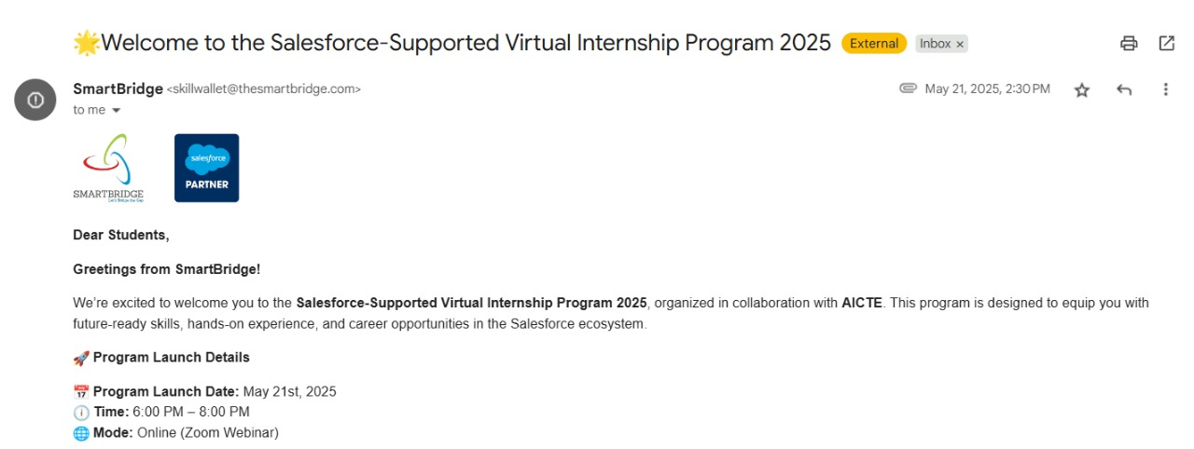

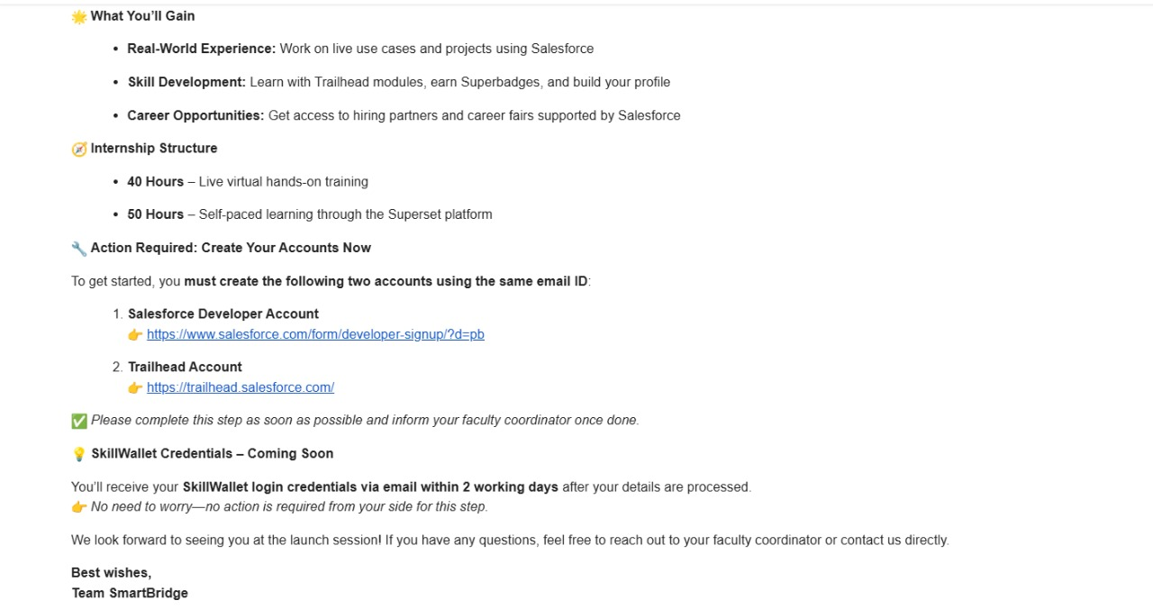

**ACKNOWLEDGEMENT**

I am pleased to present this report as part of my Summer Internship Project titled “**WhatNext Vision Motors: Shaping the Future of Mobility with Innovation and Excellence**.” This page outlines the key objectives, implementation strategy, and automation processes developed during the project. This digital transformation aims to reduce manual dependency and errors by automating dealer assignments based on customer location, preventing out-of-stock orders, and streamlining communication through dynamic order status updates and email notifications. By combining Apex triggers, batch processes, and scheduled Apex jobs, the system brings precision, speed, and reliability to order fulfillment processes.

First, I am grateful to Prof.**Manoj Arora**, the Vice Chancellor of SRM University, AP, and Prof. **D. Narayana Rao**, the Dean of the university, for giving me the chance to take part in this internship as part of my studies.

I am especially thankful to my industry mentor, **Dr.Rakesh Bhoomani** at Smart Bridge. Their ongoing guidance and expert advice throughout the project helped me understand how things work in the industry and use my technical knowledge effectively.

I also want to thank my faculty mentor, **Dr.Medipally Rampavan**, from the Department of Computer Science and Engineering at SRM University, AP. Their helpful feedback and support were really important in shaping the project.

Lastly, I appreciate the team at WhatsNext Vision Motors for providing me with real-world exposure and access to key business processes that greatly enriched my learning

**ABSTRACT**

This project was undertaken at NextWave Motors Innovations, a forward-thinking organization dedicated to plastic waste recycling and sustainable waste management. Under the guidance of my academic and industry mentors, the objective was to integrate the Salesforce platform into the company’s core operations to automate and optimize key business processes, including inventory tracking, order management, and workflow coordination. The project focused on designing a secure and efficient data structure using Salesforce’s data modeling features.

Roles and profiles were configured to ensure that each user had appropriate access based on their responsibilities, thereby maintaining data integrity and confidentiality. Using Salesforce Flow Builder and Apex, automated processes were implemented to monitor inventory levels, generate tasks when stock dropped below a threshold, and initiate replenishment workflows without manual intervention. Additionally, automated email notifications were configured to keep the warehouse team informed about approved requests, ensuring timely restocking.

Salesforce’s reporting capabilities were leveraged to provide real-time insights into inventory status and sustainability performance. The implementation of this system has significantly improved operational efficiency, reduced manual effort, and enhanced interdepartmental coordination. Overall, this project demonstrates the practical value of Salesforce as a powerful tool for driving automation and data-driven decision-making.

**TABLE OF CONTENTS**

| **S. No.** | **Section** | **Page No.** |
| --- | --- | --- |
| 1 | Certificate | 2 |
| 2 | Joining Report | 3 |
| 3 | Acknowledgements | 4 |
| 4 | Abstract | 5 |
| 5 | Table of Contents | 6 |
| 7 | Introduction | 7 |
| 8 | Overview of the Organization | 9 |
| 9 | Plan of Internship Program | 12 |
| 10 | Background & Description | 14 |
| 11 | Main Text | 15 |
| 12 | Outcomes | 16 |
| 13 | Conclusions and/or Recommendations | 17 |
| 14 | Appendices | 18 |
| 15 | References | 20 |

**A BRIEF INTRODUCTION OF THE ORGANIZATION’S BUSINESS SECTOR**

WhatNext Vision Motors operates in the highly competitive and transformative automotive and mobility sector, where innovation, digitalization, and sustainability are reshaping traditional vehicle sales and ownership models. As global light-vehicle sales are projected to reach up to 92 million units by 2025, the automotive industry is experiencing a significant shift towards electric vehicles (EVs), hybrid models, and connected mobility services. Consumer expectations have also evolved—today’s buyers demand seamless digital experiences, personalized interactions, and real-time updates throughout their vehicle ownership journey. In response to this changing landscape, WhatNext Vision Motors has adopted a forward-looking approach by integrating a sophisticated Salesforce CRM platform to modernize its customer engagement, order management, and operational workflows.

This transformation enables the company to streamline its vehicle ordering process by auto-assigning customer requests to the nearest dealer, validating stock availability in real-time, and automating updates through scheduled Apex jobs and workflows. The use of Apex triggers and batch processing further enhances the efficiency and accuracy of back-end operations. These digital capabilities not only reduce errors and delays but also improve customer satisfaction by providing timely test-drive reminders, transparent communication, and faster service fulfillment. In a market increasingly influenced by data-driven decision-making and software-defined vehicles, WhatNext Vision Motors stands out by proactively aligning its technology stack with industry demands.

The company competes in a landscape shared by global players such as CDK Global and Tekion, which offer cloud-based automotive retail platforms, and faces growing disruption from agile EV manufacturers in China, like BYD and Nio, who are reshaping global supply chains and consumer preferences with cost-effective, smart vehicles. At the same time, OEMs like Ford and GM are investing heavily in Salesforce-powered digital ecosystems to create a 360-degree view of their customers, a direction that WhatNext Vision Motors has already begun to explore and implement. By combining cutting-edge CRM capabilities with a clear focus on customer-centricity, data accuracy, and operational agility, WhatNext Vision Motors is well-positioned to thrive in the next era of mobility. The company’s strategy not only ensures scalability and adaptability in a volatile global market but also reinforces its commitment to excellence, innovation, and future-ready automotive solutions.

**OVERVIEW OF THE ORGANIZATION**

1. Brief History

WhatNext Vision Motors was established in 2019 with the aim of transforming the automotive customer experience through innovation, digital integration, and sustainable mobility solutions. Founded by a team of automotive engineers and digital transformation experts, the company began as a mobility startup offering direct-to-consumer vehicle sales and gradually expanded into full-scale dealership enablement and CRM-led service automation. Recognizing the challenges of outdated dealership systems and fragmented customer journeys, WhatNext Vision Motors invested early in cloud-based platforms such as Salesforce to streamline its operations. Within a few years, it gained recognition for pioneering intelligent vehicle ordering systems and automated customer engagement, positioning itself as a leader in next-generation automotive commerce.

2. Business Size

WhatNext Vision Motors operates in six major Indian metro cities, with regional hubs in Delhi, Mumbai, Bengaluru, Hyderabad, Chennai, and Pune. Each hub manages a network of partner dealers and vehicle stockyards. The company processes an average of 1,500+ vehicle orders monthly, supported by a workforce of over 180 employees, including customer relationship managers, logistics coordinators, software developers, sales engineers, and marketing specialists. The organization also partners with local dealerships and service centers to ensure last-mile delivery, maintenance, and test-drive support. In the last fiscal year, WhatNext Vision Motors reported an annual revenue of INR 42 crore, backed by strategic investments from mobility-focused venture capital firms. While privately owned, the company is in early discussions for expansion into Southeast Asia and the Middle East.

3. Product Lines

WhatNext Vision Motors offers a blend of vehicle-related products and digital services, designed for modern, tech-savvy consumers and enterprise buyers:

* a) Smart Vehicle Ordering System  
  A Salesforce-powered platform that allows customers to place orders online, with intelligent assignment to the nearest dealership based on geolocation, inventory, and delivery timelines.
* b) Dealer CRM & Sales Enablement Tools  
  These tools help dealers track leads, manage test drives, automate follow-ups, and personalize sales campaigns using integrated Salesforce workflows.
* c) Connected Vehicle Data Integration  
  The company integrates telematics and connected car data to offer customers real-time insights on vehicle health, driving patterns, and predictive maintenance.
* d) Fleet & Subscription Services  
  For businesses and fleet owners, WhatNext provides customized lease and subscription models supported by digital onboarding and real-time tracking.
* e) After-Sales Automation  
  This includes automated servicing reminders, digital warranty claims, scheduled maintenance coordination, and customer feedback loops powered by AI prompts.

5. Summary of Departments

WhatNext Vision Motors is structured into several core departments, each aligned with customer satisfaction and digital innovation:

* a) Vehicle Operations & Dealer Management  
  Oversees dealer partnerships, vehicle stock coordination, and order fulfillment logistics.
* b) Customer Experience & Sales  
  Manages lead generation, digital customer journeys, test drives, and post-sales engagement.
* c) Product & Engineering  
  Develops and maintains Salesforce configurations, automation workflows, Apex triggers, and data dashboards.
* d) Marketing & Brand Strategy  
  Focuses on digital advertising, influencer partnerships, content strategy, and market expansion.
* e) Data Intelligence & Automation  
  Handles reporting, analytics, AI prompt generation, and real-time performance tracking.

**PLAN OF MY INTERNSHIP PROGRAM**

* 1. Introduction to the Department
* During my summer internship at WhatNext Vision Motors, I was placed in the Product and Engineering Department, specifically under the Salesforce Automation and CRM Innovation team. This department plays a crucial role in streamlining the vehicle ordering and dealer management lifecycle through automation, system integration, and performance tracking. Their core responsibilities include managing the Salesforce platform, configuring automation using Apex and Flow Builder, and integrating CRM processes with dealer networks, logistics systems, and customer engagement modules. The department works closely with sales, logistics, and compliance teams to digitize workflows and ensure a seamless customer journey from inquiry to vehicle delivery.
* 2. Internship Duration
* Start Date: May 15, 2025
* End Date: July 15, 2025
* Total Duration: 2 months (8 weeks)
* 3. Departments Visited and Duration of Stay
* To gain a broader understanding of the company’s operations, I had the opportunity to visit and interact with several departments:

| * Department | * Duration of Stay |
| --- | --- |
| * Product & Engineering (Salesforce Team) | * 4 weeks |
| * Vehicle Operations & Dealer Management | * 1 week |
| * Order Fulfillment & Logistics | * 1 week |
| * Customer Experience & Sales | * 1 week |
| * Data Intelligence & Reporting | * 1 week |

* These departmental visits allowed me to understand how digital tools like Salesforce impact real-time order handling, vehicle assignment, customer satisfaction, and operational visibility across the company.
* 4. Duties and Responsibilities
* My primary project during the internship was titled:  
  “Salesforce-Powered Dealer Workflow and Order Assignment Automation”  
  The objective was to build and refine an intelligent automation system within Salesforce that streamlines the dealer assignment and order management process for new vehicle bookings.
* Key tasks included:
* Learning about WhatNext Vision Motors’ vehicle ordering lifecycle and how orders were managed manually or via legacy systems.
* Studying existing Salesforce objects and data models for Products, Orders, Dealers, and Customers.
* Creating a geo-based dealer assignment logic using Salesforce Flow and formula fields.
* Building a Flow Builder process to:
* Auto-assign vehicle orders to the nearest eligible dealer based on customer PIN code and inventory.
* Generate tasks for the dealer team to initiate contact.
* Send automated emails/SMS confirmations to the customer.
* Setting up Role and Profile hierarchies to control access for sales executives, dealer managers, and regional leads.
* Creating approval workflows using Apex for order overrides or manual reassignment.

**BACKGROUND AND DESCRIPTION OF THE PROBLEM**

In today’s rapidly evolving automotive industry, businesses like WhatNext Vision Motors face growing pressure to deliver faster service, reduce operational errors, and provide seamless customer experiences—all while maintaining data security and regulatory compliance. This challenge is especially evident in areas like **vehicle order processing, dealer coordination, and customer engagement**, where departments such as sales, logistics, and customer service must work in close synchronization. When these functions rely heavily on manual steps, the company risks slower workflows, inconsistent data, and communication breakdowns, which can directly impact customer satisfaction and overall operational performance.

At WhatNext Vision Motors, these issues were particularly visible in their **vehicle order assignment and tracking systems**, which previously lacked automation and real-time visibility. As customer demand grew, the absence of intelligent workflows led to **delays in assigning orders to dealers**, missed follow-ups, limited reporting visibility, and challenges in tracking service-level commitments. Furthermore, there was **no standardized approval mechanism** for order reassignment, and access to sensitive order data was loosely controlled, posing potential data governance and privacy concerns.

To address these gaps, the company decided to **leverage Salesforce** to implement an automated, rules-based order and dealer assignment system. Salesforce was chosen for its robust capabilities in data modeling, automation (via Flow Builder), security (via Roles & Profiles), and integration with email, task, and reporting features. The goal was to build a system that could **automatically assign vehicle orders based on customer location and dealer availability**, initiate task records, route approval workflows, and provide **real-time dashboards** for tracking the complete order lifecycle.

The project focused on solving the **lack of real-time automation and structured approvals** in the dealer-order assignment process. It included designing custom Salesforce objects, developing flows for automatic task creation and tracking, integrating Apex for complex logic and approval processes, and setting up email alerts and dashboard reports to keep key stakeholders informed and aligned.

**MAIN TEXT**

**Assumptions Made**

To streamline the project and focus the implementation, the following assumptions were made:

* Each vehicle order includes the customer’s geolocation (PIN code) and preferred vehicle variant.
* Dealers have their operating zones and inventory tracked in Salesforce.
* Each order has an assigned owner (sales executive or dealer manager) responsible for processing or escalating it.
* Dealer availability and inventory levels are up to date within the system.

**Implementation and Workflow Design**

* The project began by analyzing the existing manual order allocation and tracking process.
* A new data model was created using Salesforce standard objects (Leads, Opportunities, Tasks) and custom objects for Dealer Availability and Vehicle Assignment.
* A Flow Builder was created to:
  + Monitor new incoming orders.
  + Match the customer location and vehicle model to the nearest available dealer.
  + Automatically assign the order to the dealer and create a task for the dealer manager.
* An Apex-based approval process was implemented for cases where the system could not auto-match a dealer, requiring manual override.
* Upon approval, email alerts were triggered to notify the respective dealer and internal sales team.
* Role-based access control was set up so that only authorized sales reps, dealer managers, and regional heads could view, edit, or approve orders.
* Real-time dashboards and reports were built to show key KPIs like unassigned orders, dealer response time, and task completion rate.

**Results and Observations**

The automated system significantly reduced the time and effort needed to process and assign orders:

* Real-time dealer assignment meant that customers got faster responses without needing follow-up calls.
* Task ownership and automated notifications improved accountability and communication between internal teams and external dealers.
* The approval mechanism reduced unauthorized changes and helped maintain process discipline.
* The dashboards gave sales leaders a clear overview of order volumes, dealer loads, and SLA breaches.

**Key Benefits:**

* Faster order-to-dealer assignment.
* Improved accountability via task tracking.
* Timely communications through email automation.
* Higher visibility into the entire order lifecycle.

.

**OUTCOMES**

The following outcomes were achieved by implementing the automated Salesforce workflow at WhatNext Vision Motors:

* **Real-time assignment of vehicle orders** using Flow Builder based on customer location and dealer availability.
* **Automated task generation** for dealer managers to ensure quick response to assigned orders.
* **Secure approval workflows** using Apex for manual overrides and exception handling.
* **Automated email notifications** to internal teams and dealers upon order assignment or approval.
* **Role-based access controls** using Salesforce Profiles and Roles to ensure secure handling of customer and dealer data.
* **Interactive dashboards** for tracking orders by region, status, dealer performance, and fulfillment timelines.
* **Cross-team alignment** through better visibility and consistent communication using automated alerts and status updates.
* **Reduction in manual errors**, missed assignments, and delayed approvals by digitizing key processes.
* **Scalable design** that can be extended to other workflows such as test-drive scheduling, post-sales service, or leasing programs.

**CONCLUSIONS AND RECOMENDATIONS**

**Conclusions**

The integration of Salesforce automation into WhatNext Vision Motors’ vehicle ordering and dealer assignment process brought measurable improvements in operational efficiency, customer responsiveness, and data governance. The use of Flow Builder and Apex allowed for the creation of intelligent, rule-based workflows that reduced dependency on manual effort, increased accountability, and improved coordination across departments. The implementation of dashboards and access controls further ensured data visibility and security, allowing leadership to make informed decisions based on real-time metrics. Overall, the project demonstrated the powerful role that CRM automation and data intelligence can play in modernizing business operations within the automotive industry.

**Recommendations**

* Mobile Enablement: Equip dealer managers and field agents with Salesforce mobile access to update order status or approve tasks in real time.
* Training & Support: Conduct regular training for internal users and dealer partners to ensure effective system usage and awareness of new features.
* AI Integration: Consider integrating AI features like Salesforce Einstein to predict dealer availability or customer order preferences for smarter routing.
* Expand Automation: Extend the current system to automate related processes such as test-drive scheduling, loan document verification, and service request tracking.
* Feedback Loop Automation: Add flows to capture and respond to customer feedback automatically after each completed order to enhance the post-sales experience.
* Data Sync with IoT Systems: Explore integration with connected car systems or inventory sensors to feed real-time vehicle availability directly into Salesforce.

**APPENDICES**

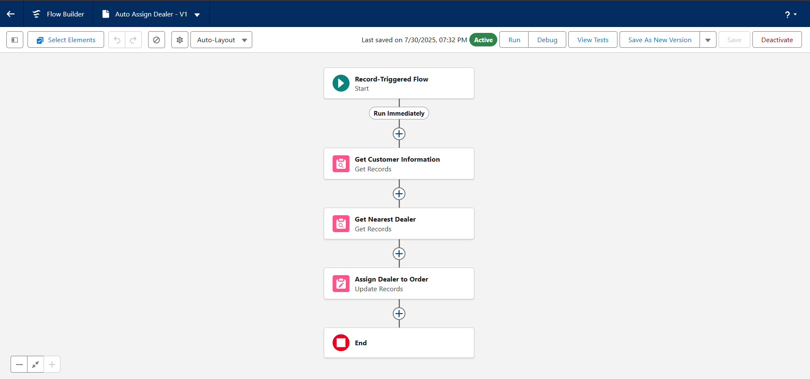

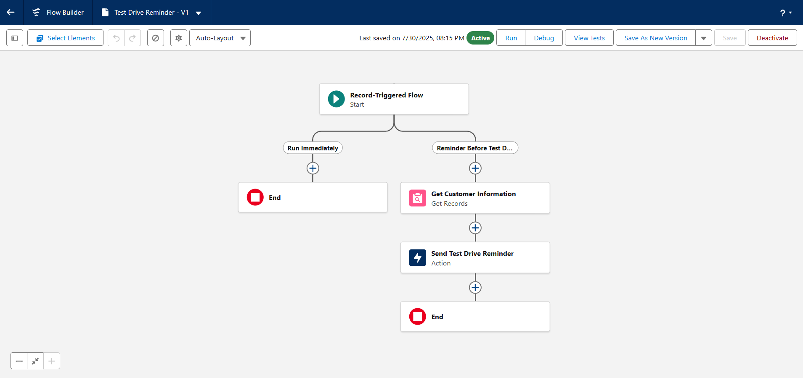

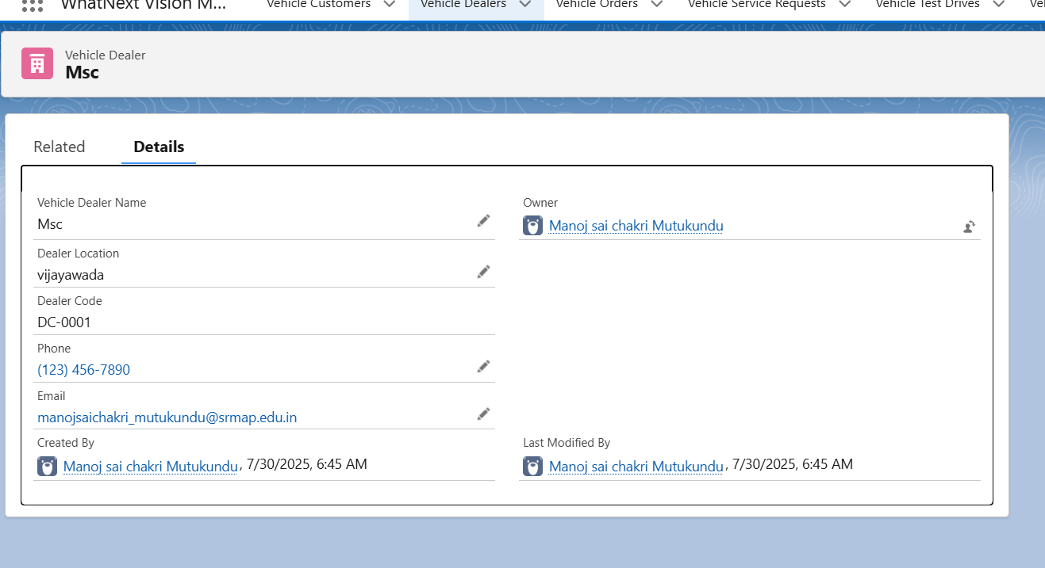

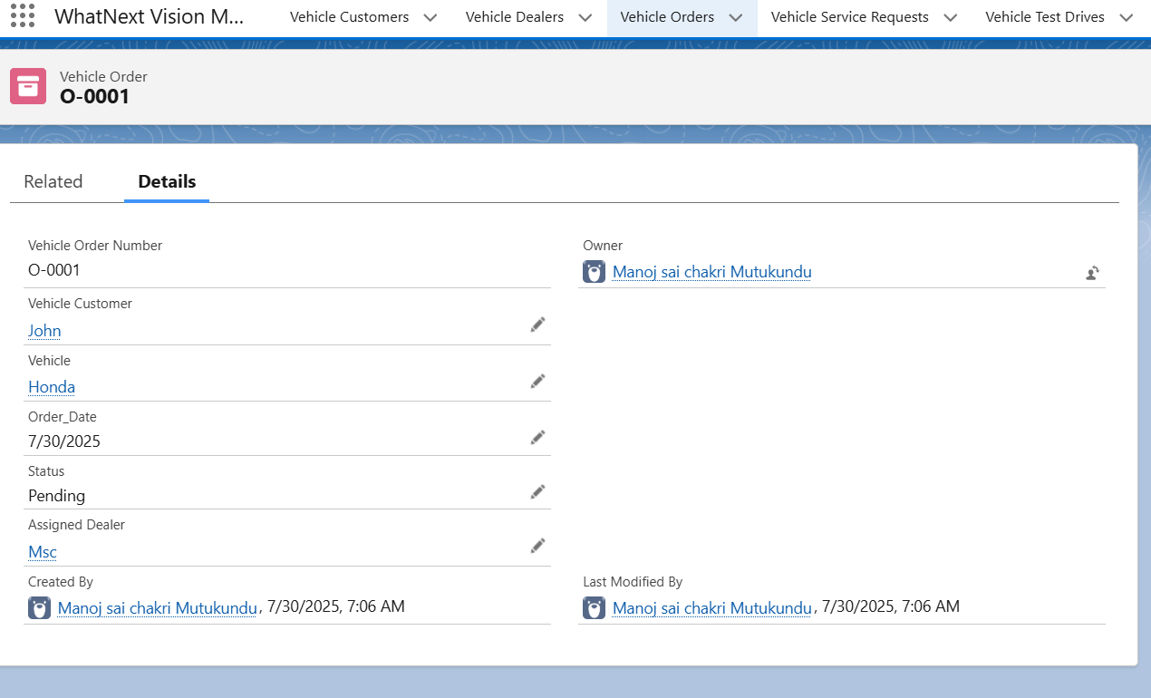

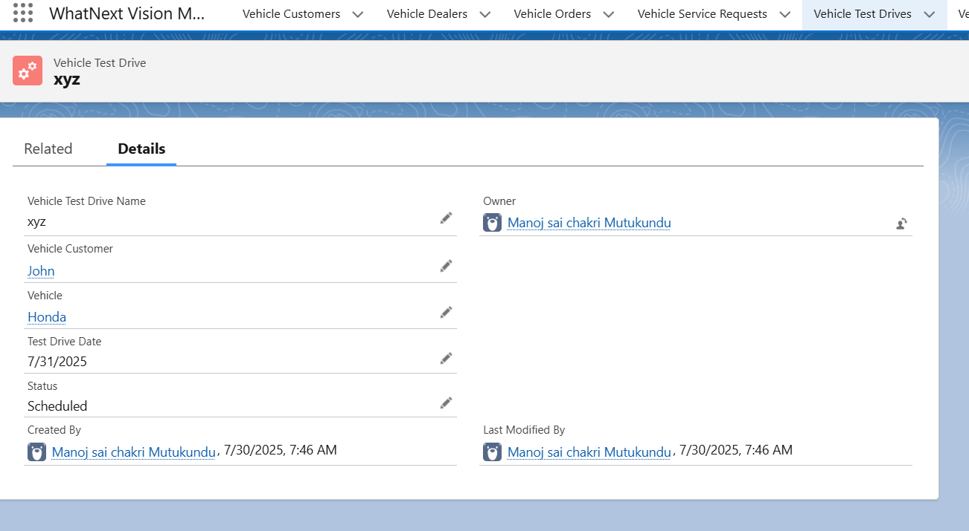

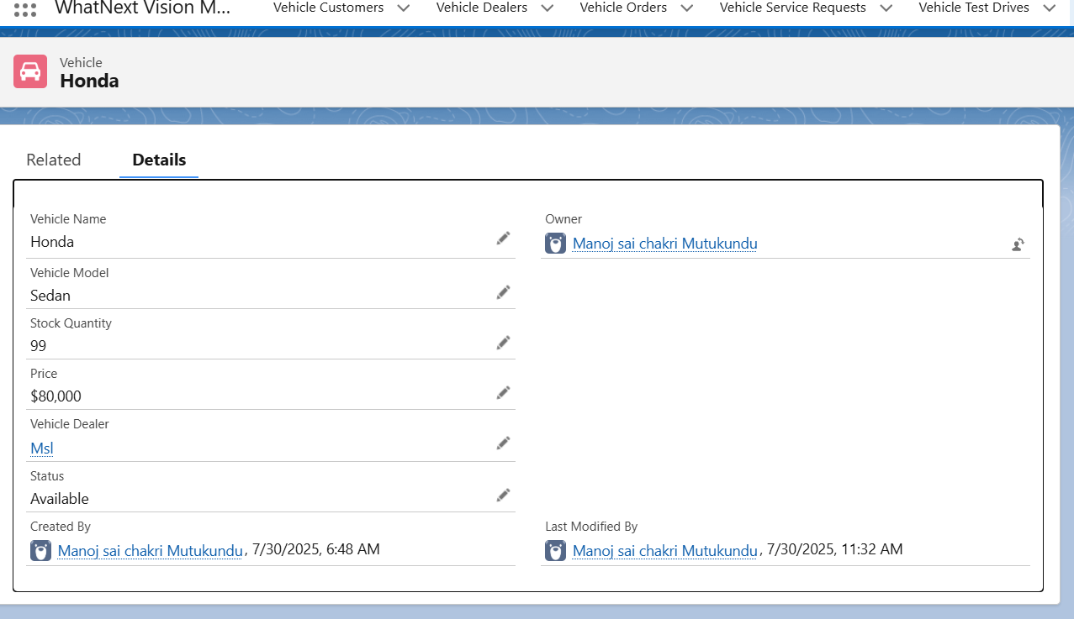

**REFERENCES**

* Salesforce Documentation Team, Using Flow Builder to Streamline Business Processes, Salesforce, 2024.
* Available at: https://help. salesforce. com/s/articleView? id=sf. flow_build. htm
* Salesforce Developers, Apex Programming Guide, Salesforce Platform Resources, 2023 Edition.
* Available at: https://developer. salesforce. com/docs/atlas. en-us. apexcode. meta/apexcode/
* Government of India, Ministry of Environment, Forest and Climate Change, Guidelines on Plastic Waste Management Rules, Official Gazette Notification, Revised Editions: 2016, 2018, 2021.
* McKinsey & Company, Towards a Circular Economy: India’s Waste Management Approach, Sustainability Insights Report, 2021.
* Available at: https://www. mckinsey. com/business-functions/sustainability
* Replastix Innovations, Internal SOP Document on Inventory and Automation Workflows, Version 2.0, Company Archive, 2025.